**Assignment 2**

**Create Table**

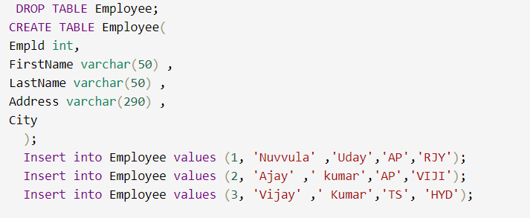

**Update And Delete Table**

**Create Tables**

**Inner Join**

**Left Join**

**Right Join**

